1. When I choose against quotation option-- after selecting a quotation it gives me error
Could not load data: TypeError: Instance of 'JSArray<dynamic>': type 'List<dynamic>' is not a subtype of type 'List<_InvoiceLineRow>'
same error when I am selecting Sales order |
Could not load data: TypeError: Instance of 'JSArray<dynamic>': type 'List<dynamic>' is not a subtype of type 'List<_InvoiceLineRow>'
2 UI/UX – On the invoice list when I click “New Invoice” is asking to selection Direct/Agaisnt Order/Agaist customer. We do not want that, It should only open sales screen
On sales scree, it should give 3 options, “Direct”, “Against Quotation” “Against Order” in same line where it “Cash” or “credit”, when I choose Against order or quotation, it should show me list to choose from in popup window, once I select order or quotation, IT should show selected number and date in same line (line one)
Currency should be default from Sales order or sales quotation and should not be editable
In case of cash sales, invoice currency will always be local currency and exchange rate will not be editable, discount in header, should be in same line as currency rate.
Please check this below image, this add line section just occupying space, can we remove it and add this (+) icon with delete (X) icon in product line. So after each product there will be (+) icon so that user can add product.

Navigation: after entering the discount in line, if user press enter, navigation should be on (+) button so that he can add new product. I want to make it quick invoice and user should be able to do everything from keyboard only without touching mouse. When User click on (+) focus should be on product dropdown, I am not able to select product from product dropdown by pressing UP and Down key on keyboard, it is not working. Can you please make all dropdown working with UP and Down key.

Please look at below image, there is plenty of space in right still Tax and other fields are small in width, this issue is with almost all screens. Why is this responsiveness missing in our application? Is it hard to fix?
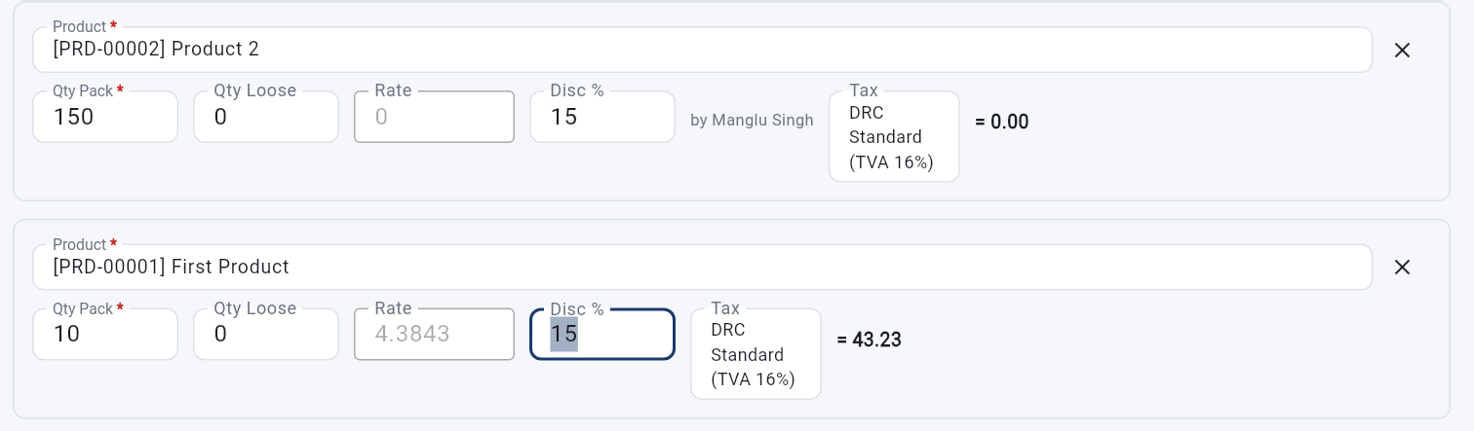
Do not show Discount approver name “By Username” in each line, in fact no need to show

Please check below image, it looks like we are wasting too much space, please make sure UI is good.
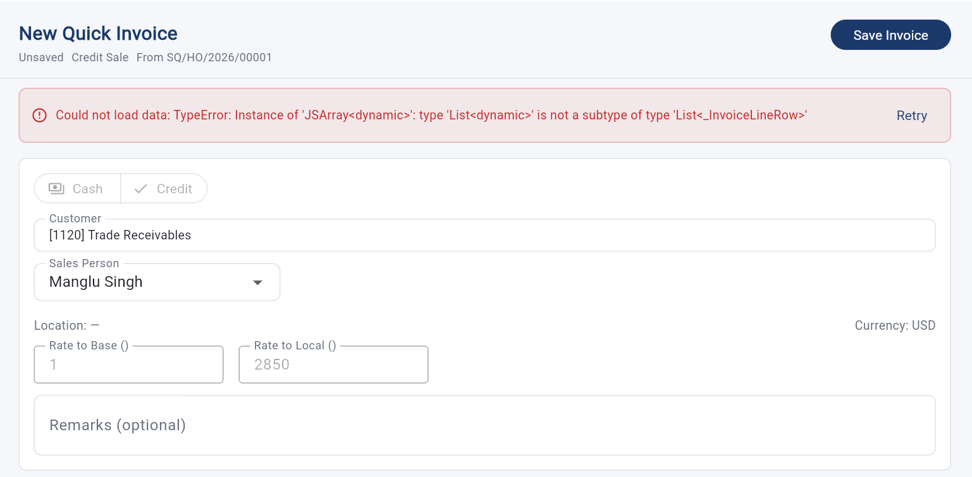
rest of the things will check later , when you fix all these.
I have a generic question, is UI/UX a problem in flutter? Why we are not able to fix UI/UX issues, we are coding very well but UI/IX is very ugly in entire application. Just look at the below image, height of app fields is not same, we have tried fixing it many times, but no success.
should we have to redesign our application, or did we made a big mistake anywhere in the beginning, so that is became very hard to fix them? Do we need to revisit our application in terms of UI/UX?
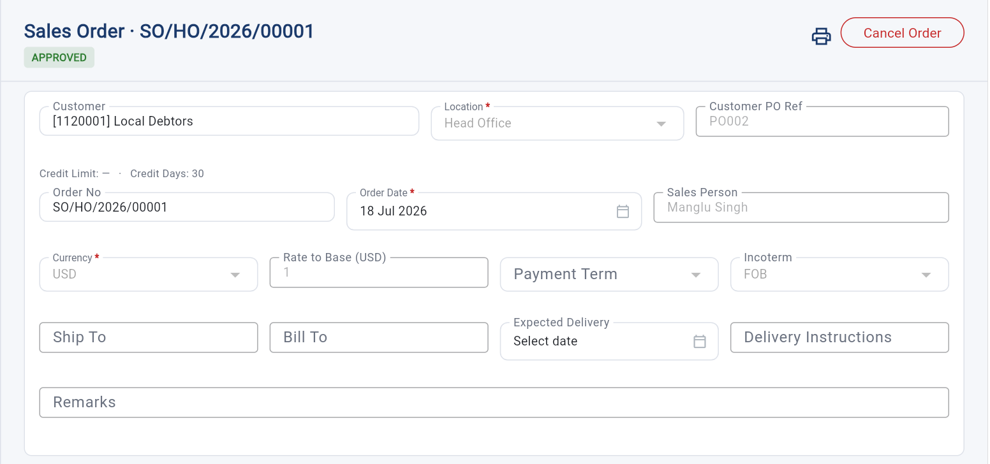

Our print (on all screens) dies not show prepared by name, wheil it should pick username who created that document, also authorized by should also come from user who approved it in the system, this think is missing on every print we made so far.
